ORTHOPAEDIC INSTRUMENTS
External Fixators
Aesculap Type Clamps - S.S.
Intended Use
Aesculap-type stainless steel clamps are essential external fixator components used in veterinary orthopaedic surgery for fracture fixation in dogs and cats. They securely connect 8 mm tubular connecting rods to Schanz screws, forming stable external skeletal fixator (ESF) frames for long-bone fracture management. | 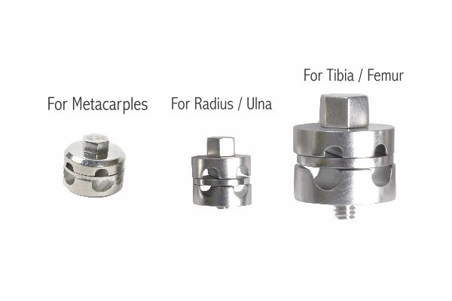
Function
Each clamp consists of two precision-machined stainless steel jaws tightened by a central nut. One jaw grips the Schanz screw pin and the other grips the connecting rod. Tightening the nut locks both elements simultaneously, creating a rigid, angularly stable connection that resists the bending and torsional forces generated during weight-bearing.
Advantages
Corrosion-Resistant Stainless Steel Construction: Grade 316L surgical stainless steel resists autoclave sterilisation cycles and biological fluid exposure, maintaining clamping torque and dimensional accuracy throughout extended fixation periods without galvanic corrosion risk.
Secure Multi-Directional Locking: The dual-jaw design allows the Schanz pin and rod to be positioned at any angle before final tightening, accommodating complex fracture geometries and enabling intraoperative frame adjustments without compromising construct rigidity.
FAQ
Q: What rod diameter do Aesculap type clamps accept?
A: Aesculap-type clamps are designed for 8 mm diameter stainless steel tubular connecting rods, which pair with standard Schanz screws used in small and medium veterinary external fixator constructs.
Q: Can these clamps be resterilised?
A: Yes. Stainless steel construction allows repeated autoclave sterilisation at standard 134 °C cycles without degradation of clamping performance or surface integrity.

ORTHOPAEDIC INSTRUMENTS
External Fixators
Compression-Distraction Rod for Radius-Ulna
Intended Use
The compression-distraction rod is a specialised veterinary orthopaedic instrument designed for controlled axial compression or distraction across fractures and osteotomies of the radius and ulna in small animals. It is used in fracture fixation, limb lengthening and deformity correction procedures in dogs and cats. | 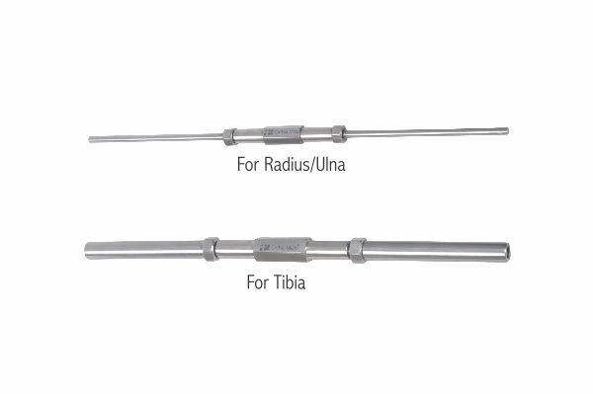
Function
A central threaded barrel connects two rod-clamping jaws. Rotating the barrel clockwise draws the jaws together, applying axial compression across the fracture site. Counter-rotation progressively separates the jaws, generating controlled distraction. Calibrated markings on the barrel allow the surgeon to quantify the compression or distraction distance applied in millimetres.
Advantages
Precise Axial Force Control: The fine-pitch threaded mechanism delivers incremental compression or distraction in sub-millimetre steps, allowing the surgeon to optimise interfragmentary compression for primary bone healing without over-loading the cortex.
Anatomy-Specific Design for Radius-Ulna: Dimensioned for the narrow interosseous space of the canine and feline antebrachium, the slender rod profile avoids soft-tissue impingement while maintaining adequate mechanical stiffness across the paired-bone segment.
FAQ
Q: What species is this rod used for?
A: It is primarily used in dogs and cats for radius and ulna fracture fixation, osteotomy compression, and limb lengthening procedures within external fixator frames.
Q: How much compression can be applied?
A: The threaded mechanism typically generates up to 10–15 mm of travel, providing sufficient compression for fracture gap closure or distraction for gradual bone transport osteogenesis.

ORTHOPAEDIC INSTRUMENTS
External Fixators
External Fixator - Distractor Mini - Double Rod
Intended Use
The mini double-rod distractor is a compact veterinary external fixator component used for controlled bone distraction in small animal limb lengthening, fracture reduction and joint arthrodesis. It is particularly suited for the distal limbs of cats and small-breed dogs where space constraints demand a low-profile construct. | 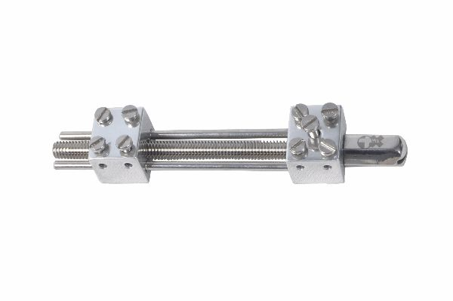
Function
Two parallel threaded rods pass through a central body housing a calibrated advancement mechanism. Turning the adjustment nut simultaneously displaces both rods, generating symmetric distraction force across the fixator frame. The dual-rod design increases rotational stability, preventing angular deviation during the gradual bone transport phase.
Advantages
Enhanced Rotational Stability: The twin-rod configuration prevents axial rotation of bone segments during distraction osteogenesis, ensuring straight regenerate bone formation and predictable limb alignment in small animal patients.
Low-Profile Mini Design: Reduced component dimensions minimise soft-tissue irritation and patient discomfort during the extended fixation period, improving compliance and reducing the risk of pin-tract complications in toy breeds and cats.
FAQ
Q: What is the distraction rate for bone transport in small animals?
A: The standard distraction rate is 1 mm per day divided into four 0.25 mm increments, applied after a latency period of 5–7 days post-osteotomy to allow early callus formation.
Q: Is the double-rod distractor compatible with standard ESF systems?
A: Yes. It interfaces with standard Schanz screws and connecting rods used in type I and type II external skeletal fixator configurations for small animals.

ORTHOPAEDIC INSTRUMENTS
External Fixators
External Fixator - Distractor Mini - Single Rod
Intended Use
The mini single-rod distractor is a lightweight veterinary orthopaedic external fixator component used for uniplanar distraction or compression across fractures and osteotomies in small animals. It facilitates fracture reduction and limb lengthening in cats and small-breed dogs within a compact, low-mass construct. | 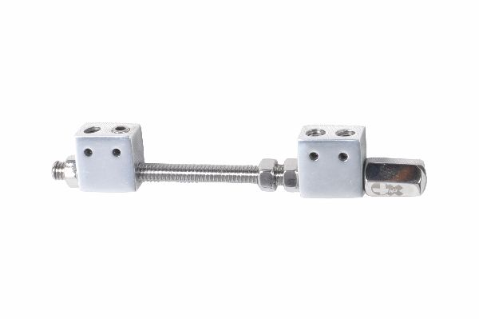
Function
A single central threaded rod passes through a body with a graduated adjustment collar. Rotating the collar advances or retracts the rod relative to the fixed clamp end, producing measurable linear distraction or compression. Calibrated markings allow the surgeon to track cumulative distraction distance and maintain the prescribed osteogenesis protocol.
Advantages
Minimal Weight and Bulk: The single-rod configuration reduces overall frame mass, decreasing the load applied to Schanz screw-bone interfaces and lowering the incidence of pin-tract loosening in lightweight small animal patients.
Simple Intraoperative Adjustment: A single graduated collar provides immediate tactile and visual feedback during distraction, enabling accurate incremental adjustments by the owner or nursing staff during the postoperative distraction phase.
FAQ
Q: When is a single-rod chosen over a double-rod distractor?
A: Single-rod distractors are preferred for simple uniplanar distractions in very small patients where frame weight is critical; double-rod models are chosen when rotational stability is the primary concern.
Q: Can this distractor be used for compression as well?
A: Yes. Reversing the adjustment direction applies axial compression, making it useful for fracture reduction and interfragmentary compression in acute fracture fixation cases.

ORTHOPAEDIC INSTRUMENTS
External Fixators
Femoral Large Distractor with 2 Threaded Rods
Intended Use
The femoral large distractor is a heavy-duty veterinary orthopaedic instrument used to achieve provisional fracture reduction and maintain limb length during internal fixation of femoral fractures in large-breed dogs. It applies controlled distraction across comminuted or shortened femoral segments before plate or nail application. | 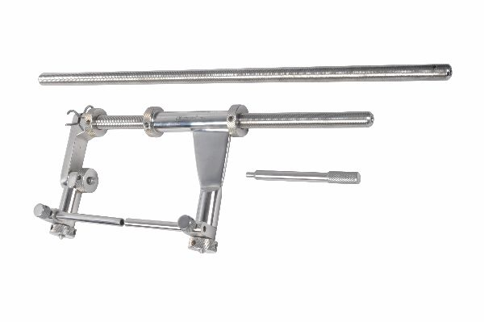
Function
Two parallel stainless steel threaded rods are anchored in cortical bone via large Schanz screws placed proximal and distal to the fracture. A central body with dual advancement nuts is advanced along the rods, generating symmetric distraction force. The rigid dual-rod frame resists bending and torsion, maintaining axial alignment during definitive fixation.
Advantages
High Load Capacity for Large Breeds: Heavy-gauge threaded rods and large-diameter Schanz screw compatibility provide the mechanical strength needed to distract the powerful musculature of the canine femur in retrievers, Labradors and German shepherd dogs.
Maintains Limb Length During Fixation: By holding the femoral segments at the correct length while the plate or nail is applied, the distractor prevents malreduction, reducing the incidence of postoperative limb length discrepancy and gait abnormality.
FAQ
Q: What size Schanz screws are used with the femoral large distractor?
A: Large femoral distractors typically accept 4.0–5.0 mm diameter Schanz screws suited to the cortical thickness of large-breed dog femora.
Q: Is the distractor removed after internal fixation?
A: Yes. The femoral distractor is a provisional reduction tool. Once the definitive plate, nail or interlocking nail construct is secured, the distractor and Schanz screws are removed.

ORTHOPAEDIC INSTRUMENTS
External Fixators
LRS Ball & Socket Clamp
Intended Use
The LRS ball and socket clamp is a multi-directional connecting component of the Linear Reduction System (LRS) external fixator used in veterinary orthopaedic fracture fixation. It allows infinite angular adjustment between the Schanz pin and the LRS rail, accommodating complex fracture geometries in dogs and cats. | 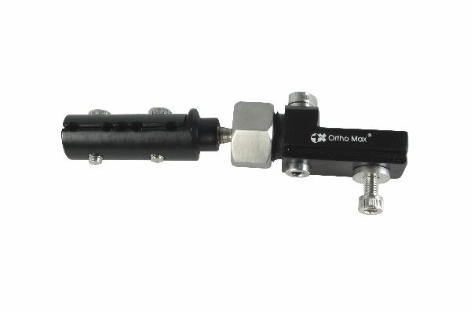
Function
A precision stainless steel ball seated within a socket housing can be positioned at any angle in three dimensions before a locking nut clamps it rigidly in place. The Schanz screw passes through the ball, while the socket body attaches to the LRS rail, allowing the pin trajectory to diverge from the rail axis without compromising fixator stiffness after final tightening.
Advantages
Three-Dimensional Angular Freedom: The ball-and-socket mechanism accommodates pin placement angles that deviate from perpendicular to the bone axis, essential when fracture location, implant size or soft-tissue constraints prevent ideal pin trajectories.
Single-Nut Locking Simplicity: Tightening a single locking nut simultaneously locks the ball position and the rail grip, reducing operative time and minimising the risk of inadvertent frame loosening from incompletely tightened multi-bolt clamps.
FAQ
Q: What angular range does the LRS ball and socket clamp provide?
A: The ball-and-socket design typically allows ±30° of angulation from the neutral axis in all planes, providing sufficient freedom for most veterinary external fixator applications.
Q: Is the LRS ball and socket clamp interchangeable with other LRS components?
A: Yes. It is designed to interface directly with LRS rails, threaded rods and Schanz screws within the modular LRS external fixator system used in veterinary orthopaedics.

ORTHOPAEDIC INSTRUMENTS
External Fixators
LRS CD Unit
Intended Use
The LRS compression-distraction (CD) unit is the central adjustment mechanism of the Linear Reduction System external fixator used in veterinary orthopaedic surgery. It provides precise axial compression or distraction across fracture sites and osteotomies in the long bones of dogs and cats during fracture fixation and limb reconstruction. | 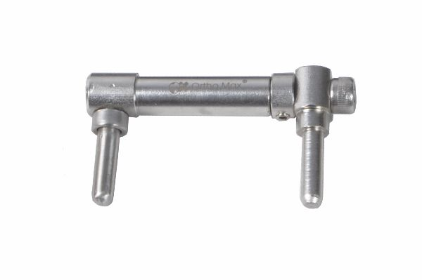
Function
The CD unit incorporates a fine-pitched internal thread engaging a drive screw housed within the LRS rail. Rotating the external knurled wheel advances or retracts the drive screw, translating one rail segment relative to the other and generating calibrated axial force at the bone level. A locking ring secures the position once the desired compression or distraction is achieved.
Advantages
Calibrated Incremental Adjustment: Graduated markings on the CD unit allow the surgeon to precisely quantify cumulative distraction in millimetres, enabling accurate execution of bone transport osteogenesis protocols without supplementary measurement tools.
Postoperative Owner Adjustment: The simple knurled-wheel design enables trained owners to perform daily distraction increments at home following veterinary instruction, reducing the number of clinic visits required during the distraction phase of limb lengthening.
FAQ
Q: How much distraction per turn does the LRS CD unit provide?
A: Each full rotation of the adjustment wheel typically advances the screw by 1 mm, allowing owners to apply the standard 0.25 mm per quarter-turn distraction protocol conveniently.
Q: Can the CD unit apply compression as well as distraction?
A: Yes. Reversing the wheel direction applies axial compression, making the CD unit suitable for both fracture reduction compression and distraction osteogenesis limb lengthening.

ORTHOPAEDIC INSTRUMENTS
External Fixators
LRS Centre Clamp
Intended Use
The LRS centre clamp is a modular connecting component of the Linear Reduction System external fixator used in veterinary orthopaedic surgery. It secures Schanz screws at the mid-segment positions of the LRS rail, providing intermediate pin fixation points for additional construct stability in complex comminuted fracture fixation cases. | 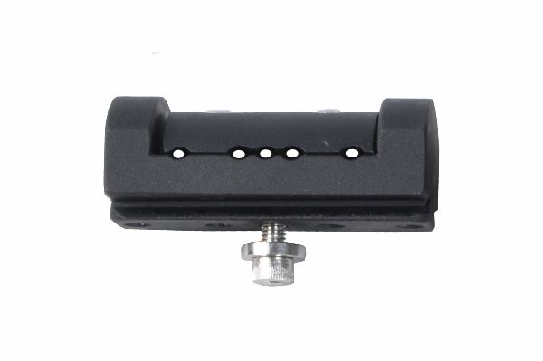
Function
The clamp body slides along the LRS rail and is fixed at the desired position by tightening a central locking bolt. A perpendicular channel through the body accepts a Schanz screw, which is clamped rigidly once seated. The symmetric design allows the Schanz screw to be positioned on either side of the rail for medial or lateral pin placement.
Advantages
Modular Mid-Segment Fixation: Additional centre clamps can be added at any position along the rail to increase the number of bone-fixation points, improving construct stiffness and distributing bone-pin interface loads more evenly across comminuted segments.
Tool-Free Rail Positioning: The slide-and-lock mechanism allows rapid repositioning along the LRS rail before final tightening, enabling intraoperative adjustments to pin spacing without removing and re-inserting components.
FAQ
Q: How many centre clamps are typically used per LRS frame?
A: Most LRS constructs use two to four centre clamps depending on fracture complexity, bone length and the number of bone-fixation points required for adequate construct stiffness.
Q: What Schanz screw sizes are compatible with the LRS centre clamp?
A: LRS centre clamps accommodate standard 3.0–5.0 mm Schanz screws, covering the pin sizes used for small to large-breed dog fracture fixation.

ORTHOPAEDIC INSTRUMENTS
External Fixators
LRS End Clamp
Intended Use
The LRS end clamp is a terminal fixation component of the Linear Reduction System external fixator used in veterinary orthopaedic fracture fixation. It is mounted at both ends of the LRS rail to secure the most proximal and distal Schanz screws, anchoring the external fixator frame to the bone segments flanking the fracture. | 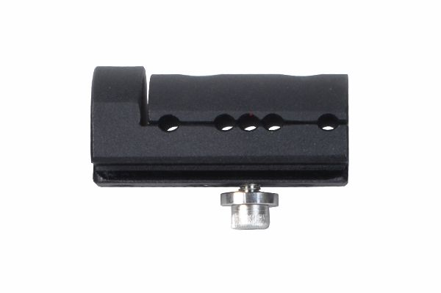
Function
The end clamp body is fixed to the rail terminus by a locking nut and incorporates a perpendicular Schanz-screw channel secured by a separate pin-locking bolt. The terminal position maximises the working distance between the most proximal and distal fixation points, optimising the mechanical lever arm and improving construct resistance to bending forces.
Advantages
Maximum Frame Span Coverage: Positioning end clamps at the rail extremities maximises the distance between outermost pins, providing the largest possible moment arm to resist bending loads at the fracture site during early postoperative weight-bearing.
Independent Pin and Rail Locking: Separate locking mechanisms for the rail attachment and the Schanz screw channel allow the pin angle to be set independently of rail position, facilitating accurate pin placement despite irregular bone contour.
FAQ
Q: How does the end clamp differ from the centre clamp?
A: End clamps are designed for rail terminus positions and feature a terminal body profile; centre clamps slide along the full rail length and are used at intermediate positions between the end clamps.
Q: Can LRS end clamps be used as intermediate clamps if needed?
A: The end clamp can be repositioned along the rail in some LRS designs, but dedicated centre clamps provide a more secure intermediate grip and are preferred for mid-segment fixation.

ORTHOPAEDIC INSTRUMENTS
External Fixators
LRS Rail Patti
Intended Use
The LRS rail patti is the primary connecting bar of the Linear Reduction System external fixator used in veterinary orthopaedic surgery. It forms the longitudinal backbone of the ESF frame, linking all clamps and the CD unit to create a rigid construct for fracture fixation and bone transport in dogs and cats. | 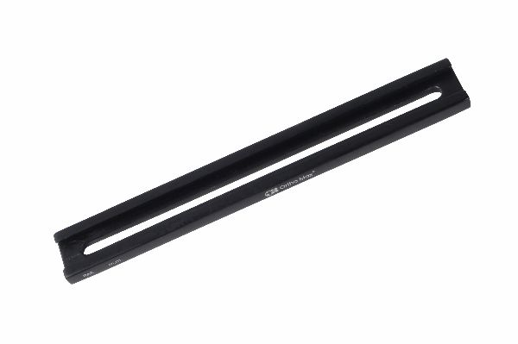
Function
The rail patti is a precision-machined stainless steel bar with a standardised cross-sectional profile that mates with the sliding channels of all LRS clamps and the CD unit. Its length determines the working span of the fixator frame. Multiple rail sections can be joined end-to-end using connecting components to create frames spanning very long bone segments.
Advantages
High Bending Stiffness: The solid stainless steel rail section provides substantially greater bending stiffness than tubular connecting rods of equivalent diameter, reducing frame deflection under weight-bearing loads and improving fracture-site mechanical stability.
Standardised Modular Interface: The uniform rail cross-section ensures all LRS clamps, the CD unit and accessory components engage the rail with consistent clamping force, guaranteeing a reliable construct regardless of which clamp positions are occupied.
FAQ
Q: What lengths are LRS rail pattis available in?
A: LRS rails are typically available in lengths from 100 mm to 400 mm, with longer lengths or rail joining components used for very large dogs or complex bone transport cases.
Q: Can LRS rail pattis be cut to length intraoperatively?
A: Rail pattis should not be cut intraoperatively as this compromises the precision cross-section required for clamp engagement. Pre-cut lengths covering the required spans should be selected from the instrument set.

ORTHOPAEDIC INSTRUMENTS
External Fixators
LRS Swivel Clamp
Intended Use
The LRS swivel clamp is an angular adjustment component of the Linear Reduction System external fixator used in veterinary orthopaedic surgery. It allows the Schanz screw to be oriented at any angle within a single plane relative to the LRS rail, facilitating accurate pin placement in oblique fracture fixation and joint arthrodesis in dogs and cats. | 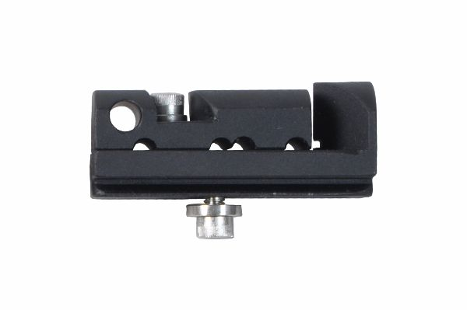
Function
A rotating jaw within the clamp body pivots around a central axis perpendicular to the rail, allowing the Schanz screw channel to swing through an arc. Once the desired pin angle is achieved, a locking nut tightens the jaw against the rail body, rigidly fixing the angle and simultaneously clamping the rail. This single-plane swivel contrasts with the full three-dimensional freedom of the ball-and-socket clamp.
Advantages
Controlled Single-Plane Angulation: The planar swivel mechanism enables reproducible, controlled pin angulation for divergent pin configurations in type II and type III ESF frames, improving construct resistance to pin pullout under cyclic loading.
Rapid Intraoperative Setting: The swivel locks with a single nut, enabling fast angle adjustment and locking during surgery, reducing the time spent on frame assembly while maintaining the angular precision required for stable fracture fixation.
FAQ
Q: What is the difference between the LRS swivel clamp and ball-and-socket clamp?
A: The swivel clamp allows angulation in a single plane only; the ball-and-socket clamp provides full three-dimensional angular freedom. The swivel clamp is preferred when only one plane of angulation is needed.
Q: Can the LRS swivel clamp be used with all LRS rail sizes?
A: LRS swivel clamps are designed for the standard LRS rail cross-section and are fully compatible with all rail lengths and other LRS modular components.

ORTHOPAEDIC INSTRUMENTS
External Fixators
LRS T Clamp
Intended Use
The LRS T clamp is a modular junction component of the Linear Reduction System external fixator used in veterinary orthopaedic surgery. It connects a secondary rail perpendicular to the primary LRS rail, enabling construction of type II and type III bilateral external fixator frames for complex fracture fixation in large dogs. | 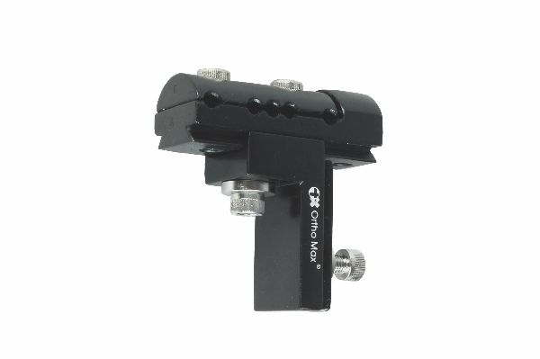
Function
The T-clamp body incorporates two orthogonal rail channels. The primary channel grips the longitudinal LRS rail while the secondary channel accepts a perpendicular rail or rod. Independent locking bolts for each channel allow both connections to be tightened separately, permitting fine adjustment of rail alignment before frame assembly is finalised.
Advantages
Enables Bilateral Frame Construction: Adding a perpendicular secondary rail via the T clamp transforms a simple uniplanar type I frame into a biplanar type II construct, substantially increasing frame stiffness and enabling fixation of more complex, highly comminuted fractures.
Independent Dual-Channel Locking: Separate locking bolts for each rail channel allow the surgeon to adjust primary and secondary rail orientations independently, providing precise frame geometry control during intraoperative assembly.
FAQ
Q: When is an LRS T clamp used instead of a standard end or centre clamp?
A: T clamps are used when a second rail must be added perpendicular to the primary rail to create a bilateral or multiplanar ESF frame for cases requiring greater construct stiffness.
Q: Is the LRS T clamp compatible with both 8 mm and 11 mm rods?
A: LRS T clamps are designed for the LRS rail cross-section; adapter components may be required to connect rods of different diameters within hybrid frame configurations.

ORTHOPAEDIC INSTRUMENTS
External Fixators
Metaphyseal Clamp - Transverse Clamp
Intended Use
The metaphyseal transverse clamp is a specialised external fixator component used in veterinary orthopaedic surgery to secure Schanz screws placed in the metaphyseal or epiphyseal regions of long bones. It is used in distal fracture fixation and periarticular fracture stabilisation in dogs and cats where pin placement near joint lines is required. | 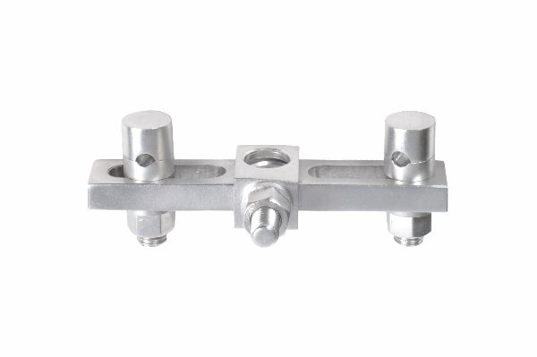
Function
The clamp body has a wide, flat jaw profile designed to distribute clamping forces across the expanded metaphyseal bone contour without stress concentration. A perpendicular Schanz-screw channel allows transverse pin insertion close to the articular surface. A transverse locking bolt tightens both the rail grip and pin fixation simultaneously.
Advantages
Near-Joint Pin Fixation: The low-profile metaphyseal design allows Schanz screw placement within 10–15 mm of the joint line, enabling external fixation of periarticular and physeal fractures where standard clamps cannot achieve adequate fixation proximity.
Wide Load-Distribution Profile: The broader jaw contact area reduces stress concentration at the rail-clamp interface in the short bone segments of the metaphysis, lowering the risk of clamp slippage under the high bending moments generated near joint lines.
FAQ
Q: What fracture types require a metaphyseal clamp?
A: Metaphyseal clamps are used for Salter-Harris physeal fractures, distal radial fractures, distal femoral fractures and periarticular fractures where fixation points must be placed close to the growth plate or joint surface.
Q: Can metaphyseal clamps be used in toy breeds?
A: Yes. Mini metaphyseal clamps sized for 2.0–3.0 mm Schanz screws are available for toy-breed and feline periarticular fracture fixation cases.

ORTHOPAEDIC INSTRUMENTS
External Fixators
Rod to Rod - Tube to Tube Clamps
Intended Use
Rod-to-rod and tube-to-tube clamps are universal external fixator connecting components used in veterinary orthopaedic surgery to join two cylindrical connecting rods or tubes at any angle. They enable construction of hybrid and multi-planar external fixator frames for complex fracture fixation in dogs and cats. | 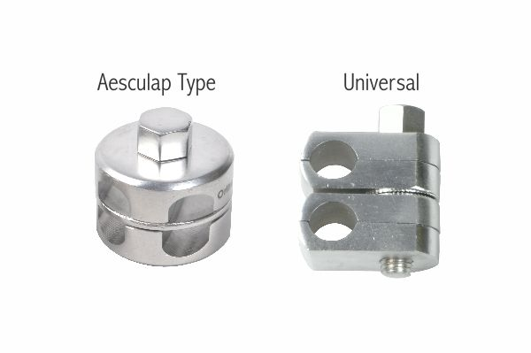
Function
The clamp body contains two parallel or angularly adjustable circular bores, each sized to grip a round rod or tube of a specified diameter. Individual locking bolts for each bore are tightened sequentially to lock each rod independently, allowing the surgeon to set the rod positions and angles before committing to final tightening during frame assembly.
Advantages
Universal Cross-Rod Connection: The dual-bore design accommodates rods oriented at any relative angle, enabling rapid construction of complex frame geometries including bilateral, triangulated and ring-hybrid external fixator configurations.
Mixed-Diameter Compatibility: Many rod-to-rod clamps are manufactured with bores sized for both 8 mm and 11 mm rods, allowing components from different external fixator systems to be combined in hybrid frames for versatile fracture management.
FAQ
Q: What rod diameters do rod-to-rod clamps accept?
A: Standard veterinary rod-to-rod clamps are available for 8 mm, 11 mm and mixed-diameter combinations, covering the rod sizes used in Aesculap-type, universal and LRS external fixator systems.
Q: Can tube-to-tube clamps be used at angles other than 90°?
A: Yes. The locking bores can be oriented at any angle during assembly; once tightened, the clamp rigidly maintains that angle throughout the fixation period.

ORTHOPAEDIC INSTRUMENTS
External Fixators
Trocar Sleeve 3-in-1 with Handle for Schanz Screws
Intended Use
The 3-in-1 trocar sleeve with handle is a multi-function veterinary orthopaedic instrument used to facilitate accurate Schanz screw insertion during external fixator application in dogs and cats. It functions as a tissue protector, drill guide and Schanz-screw guide in a single instrument, reducing soft-tissue trauma during ESF pin placement. | 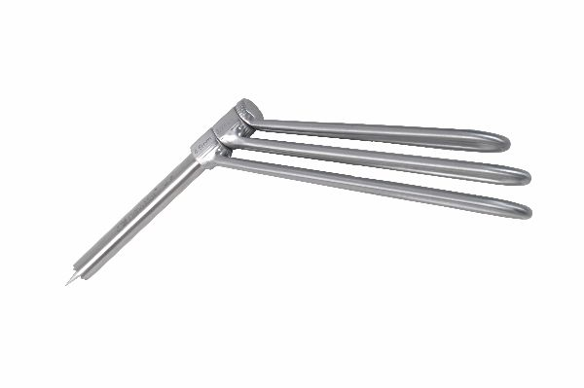
Function
The instrument consists of an outer trocar sleeve with a sharp tip for tissue penetration, an inner drill guide tube for precise cortical drilling, and a Schanz-screw guide channel aligned with the drill path. The ergonomic handle provides manual control during all three phases of use. Removing the inner components sequentially transitions the sleeve between its three functions without repositioning.
Advantages
Three Functions in One Instrument: Combining tissue penetration, drill guidance and screw insertion in a single sleeve eliminates multiple instrument exchanges, reducing operative time and the risk of drill guide malalignment between the drilling and screw-insertion steps.
Soft-Tissue Protection Throughout Insertion: The outer sleeve remains in situ during drilling and screw insertion, shielding surrounding muscles, vessels and nerves from rotating drill bits and Schanz screw threads — critical in the heavily muscled thigh and antebrachium.
FAQ
Q: What drill sizes are compatible with the 3-in-1 trocar sleeve?
A: The inner guide channel accepts standard ESF pilot drill bits sized for the Schanz screws in the set, typically 2.0–4.0 mm diameter depending on the patient size.
Q: Can the sleeve be used for both cortices during bicortical Schanz screw placement?
A: Yes. The sleeve length is designed to guide the drill and screw through both cortices of the bone with a single insertion, ensuring accurate bicortical fixation.

ORTHOPAEDIC INSTRUMENTS
External Fixators
Tubular Rod 11mm (for Universal Clamps)
Intended Use
The 11 mm diameter tubular connecting rod is the primary frame component used with universal external fixator clamps in veterinary orthopaedic surgery. It forms the longitudinal connecting bar of ESF frames used in fracture fixation of medium to large-breed dogs, providing the high bending stiffness required for load-bearing limb segments. | 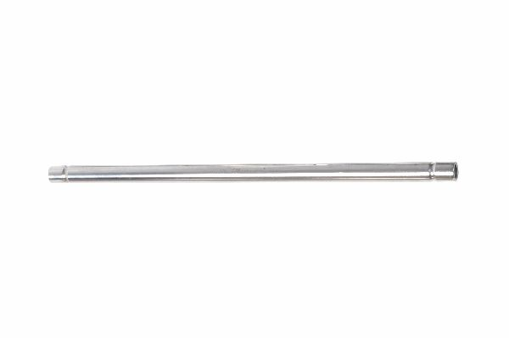
Function
The hollow tubular cross-section provides an optimal strength-to-weight ratio. Universal clamps grip the tube exterior via hardened inner jaws, distributing clamping forces around the circumference to prevent ovalling deformation. The 11 mm diameter gives substantially greater section modulus than smaller tubes, resisting the bending moments generated during canine ambulation.
Advantages
High Bending Stiffness for Large Patients: The 11 mm diameter delivers a section modulus suitable for medium and large-breed dogs, reducing intraoperative and postoperative frame deflection that could cause fracture-site micromotion and delayed union.
Lightweight Tubular Construction: The hollow tube reduces overall frame weight compared with a solid rod of equivalent diameter, lowering patient discomfort and reducing the bending load applied to Schanz screw-bone interfaces during ambulation.
FAQ
Q: What is the difference between 8 mm and 11 mm tubular rods?
A: The 11 mm rod is significantly stiffer and suited to medium and large-breed dogs; the 8 mm rod is used with Aesculap-type clamps in small to medium-breed fracture cases where a lighter frame is appropriate.
Q: Can 11 mm rods be cut to length?
A: Yes. Stainless steel tubular rods can be cut to the required length using an orthopaedic rod cutter, and the cut end should be smoothed to prevent clamp damage and tissue abrasion.

ORTHOPAEDIC INSTRUMENTS
External Fixators
Tubular Rod 8mm (for Aesculap Type Clamps)
Intended Use
The 8 mm diameter tubular connecting rod is the standard connecting bar for Aesculap-type external fixator clamps used in veterinary orthopaedic surgery. It forms ESF frames for fracture fixation in cats and small to medium-breed dogs, providing the necessary stiffness while maintaining a low-profile, lightweight construct. | 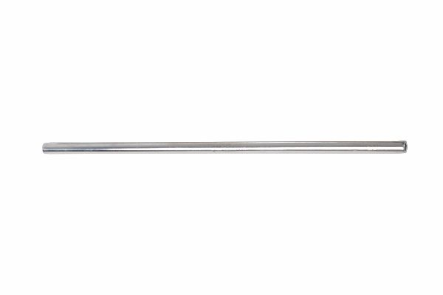
Function
The 8 mm stainless steel tube engages the inner jaws of Aesculap-type clamps, which grip the rod circumferentially when the central locking nut is tightened. The smaller diameter compared with 11 mm universal rods reduces frame mass and width, minimising skin-tube contact and soft-tissue complications during the extended fixation period in small patients.
Advantages
Optimised for Small Animal ESF: The 8 mm diameter is specifically matched to Aesculap-type clamp bore dimensions, ensuring secure clamping without ovalling or rod slippage at the clinically relevant torque levels used in small and medium-breed external fixation.
Low Frame Mass Reduces Pin Stress: Lighter rods generate less gravitational bending moment at the Schanz screw-bone interface, reducing the incidence of progressive pin loosening and osteolysis around ESF pins in cats and small dogs.
FAQ
Q: Are 8 mm rods interchangeable with 11 mm universal clamp systems?
A: No. Aesculap-type clamps are specifically bored for 8 mm rods and universal clamps for 11 mm rods; mixing rod diameters with incompatible clamps results in insecure fixation.
Q: What length rods are typically used in feline external fixation?
A: For most feline long-bone fractures, rods of 80–150 mm length are sufficient; precut lengths or intraoperative cutting to fit are both acceptable practice.

ORTHOPAEDIC INSTRUMENTS
External Fixators
Universal Clamps S.S.
Intended Use
Universal stainless steel clamps are versatile external fixator connecting components used in veterinary orthopaedic surgery to join Schanz screws to 11 mm tubular connecting rods. They are used in fracture fixation of medium to large-breed dogs in type I, II and III ESF frame configurations for long-bone fracture stabilisation. | 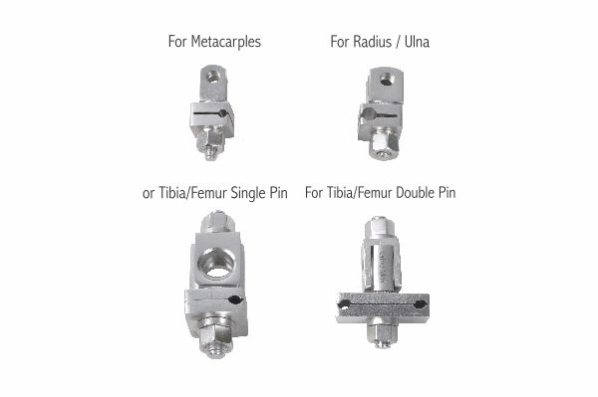
Function
The clamp incorporates two independently adjustable jaws within a single stainless steel body. One jaw grips the Schanz screw and the other grips the tubular rod. Each jaw is locked by a separate bolt, allowing the pin angle and rod position to be set independently before final tightening. The robust body withstands the high clamping forces required in large-breed ESF constructs.
Advantages
Independent Dual-Jaw Adjustment: Separate locking bolts for the Schanz screw and rod jaws allow the pin trajectory and rod position to be optimised independently, enabling precise frame assembly even when bone anatomy or soft-tissue constraints complicate pin placement.
Grade 316L Stainless Steel Durability: Surgical-grade stainless steel construction withstands repeated sterilisation and the sustained mechanical loads of large-breed canine weight-bearing, maintaining clamping torque without stress relaxation over the typical 6–12 week fixation period.
FAQ
Q: What Schanz screw diameters do universal clamps accept?
A: Universal clamps typically accept 3.0–5.0 mm Schanz screws, covering the pin sizes used in medium to large-breed canine external fixation from border collies to giant breeds.
Q: How much torque should be applied when tightening universal clamps?
A: Manufacturer-recommended torque is typically 4–6 Nm per bolt. Over-tightening can damage the rod surface and reduce clamp reusability; a torque-limiting screwdriver is recommended.

